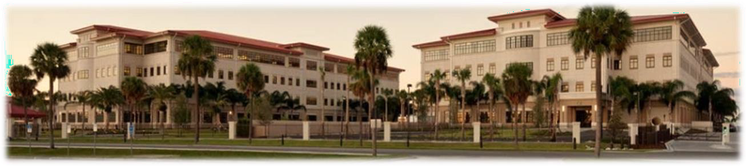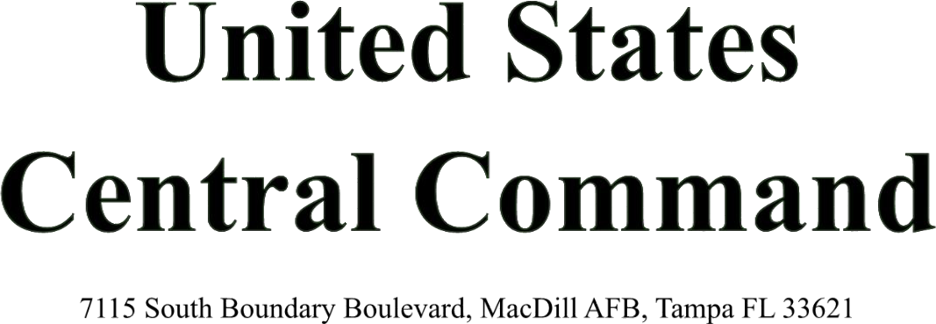

MacDill

Version 2.6, September 2022
1

WELCOME GUIDE (WG) SUMMARY OF REVISION
This revision updates previous edition version 2.5 dated April 2022. This revision updates commander’s welcome letter, EFMP information, and digital links.

Table of Contents
CENTCOM Mission, Vision, and Command Priorities / Key Phone Numbers 3
CENTCOM Commander’s Welcome Letter 4
CENTCOM In and Out-processing 5
CENTCOM Family Readiness Program 6
MacDill AFB EFMP-Family Support 7-9
MacDill AFB School & Child Care Information 10-13
Local Off Base Assistance 14-16
MacDill AFB Facilities 17-21
MacDill AFB Key Phone Numbers 23
Places to Eat Near MacDill AFB 24
MacDill AFB Map 25
Tampa Bay Area Attractions 26
Tampa Bay Area Map 27
Central Tampa Map 28

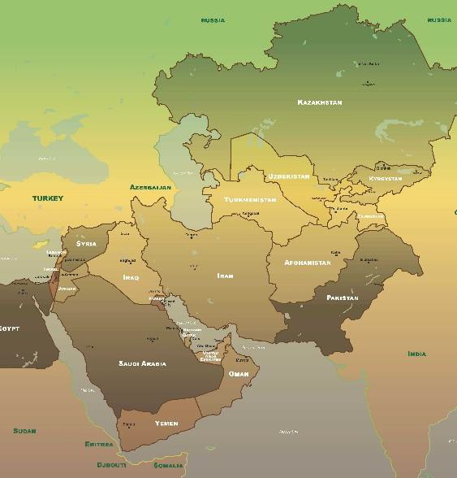
USCENTCOM Mission, Vision, and Priorities
Mission: United States Central Command (USCENTCOM) directs and enables military operations and activities with allies and partners to increase regional security and stability in support of enduring U.S. interests.

Vision: A more stable and prosperous region with increasingly effective governance, improved security, and transregional cooperation to counter state and non-state actors posing a threat to U.S. interests.

Commander’s Priorities:
- Deterring Iran
- Counter Violent Extremist Organizations
- Competition Strategically
- Regional Constructs
- Integrated Air and Missile Defense/Counter Unmanned Aerial Systems

CENTCOM Key Phone Numbers and Websites
In/Out Processing Center 813-529-0575 / 7277
Manpower and Personnel Directorate . . . . . . . . . . . . . . . . . . . . . . . . . . . . . . . . . . . 813-529-1002
USCENTCOM Clinic . . . . . . . . . . . . . . . . . . . . . . . . . . . . . . . . . . . . . . . . . . . . 813-827-9715

https://www.centcom.mil/
https://www.centcom.mil/ABOUT-US/COMMAND-PRIORITIES/

USCENTCOM Commander’s Welcome Letter

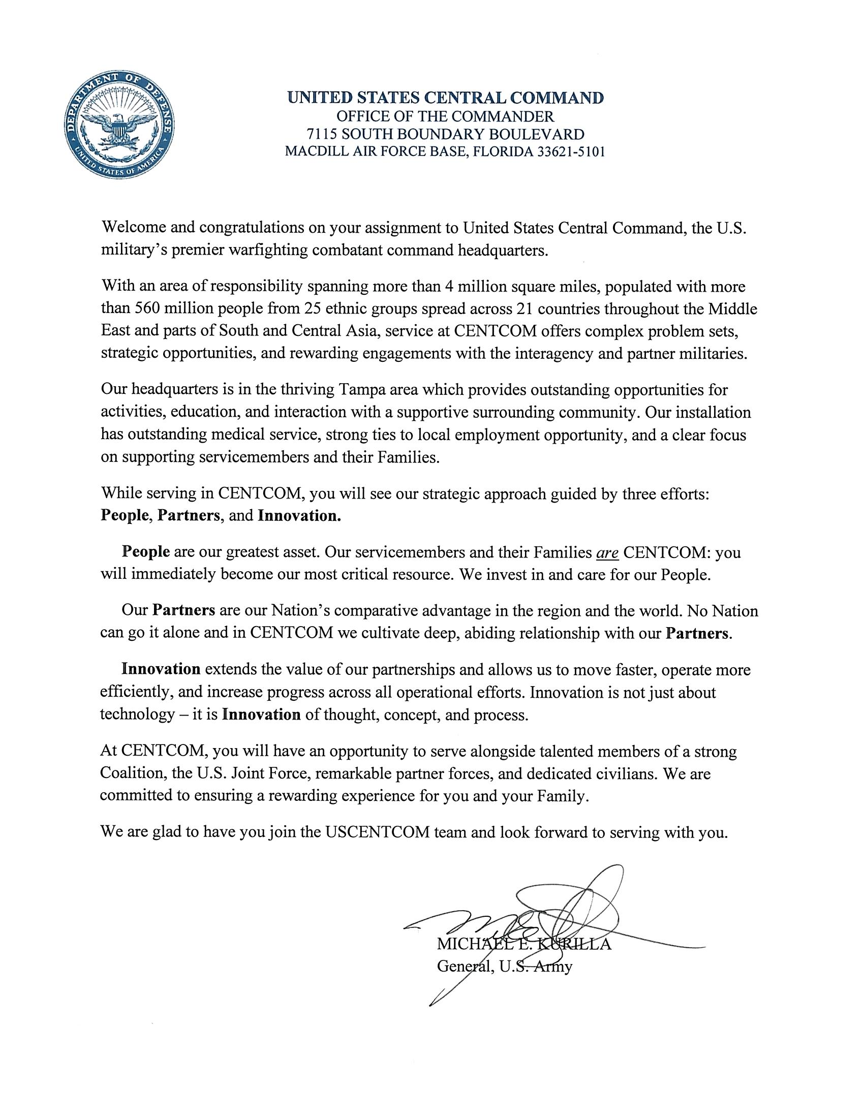

USCENTCOM In-Processing Procedures
HOURS OF OPERATION: Monday-Friday: 0800–1600 (closed federal and training holidays)

LOCATION: CENTCOM In-Processing Center, 7115 S. Boundary Blvd, Bldg. 571, Room 114 (to the left inside the Visitor's Center)

REQUIRED ITEMS:

QUARANTINED MEMBERS WILL NOT IN or OUT-PROCESS IN PERSON.
See Note 1 & 2
- All newcomers (military, civilian, contractor) MUST have a SPONSOR or supervisor from their Directorate with them. If not, they will be redirected to contact their sponsor/supervisor. If no one is available from their assigned Directorate, the newcomer WILL NOT in-process. See Note 1 & 2
- Out-Processing members must sign-in on the kiosk in person to receive a checklist, no sponsor needed.
- All Active Duty members MUST provide their ETP. Contact your Directorate for more information.
- All military members MUST be in uniform and have at least two copies of their orders.
- Army personnel will also need to provide their leave form(s).
- Contractors MUST have a CAC card from their assigned Contracting Company.
- All personnel visiting the In-Processing Center MUST have a current CAC.

NOTES:
- 1. If you must quarantine, DO NOT show up to CENTCOM in person. Contact your Directorate sponsor/supervisor for instructions or reference the Command Guidance for HQ USCENTCOM Staff.
- 2. If you are feeling any COVID symptoms, self-quarantine. DO NOT in-process in person. Contact your Directorate sponsor/supervisor immediately. Per Command Guidance for HQ USCENTCOM Staff.
- 3. No one is available outside of normal business hours for in-processing or signing leave form(s).
- 4. Electronic devices (cell phones, tablets, smart watches, etc.) are not allowed in any building on the CENTCOM compound.
- 5. All personnel will in-process with the In-Processing Center (IPC) prior to visiting the SSO Office for their Security Badge

Contact the HQs CENTCOM In-Processing Center at 813-529-0575/7277.

USCENTCOM Family Readiness Program
Our Mission: Our mission is to connect all members of the USCENTCOM family to each other, the local community, and the resources of MacDill Air Force Base and the greater Tampa Bay area.

Our program enhances the quality of life and well-being by developing and operating programs that provide information, offer support, and outreach, and promote involvement.

The USCENTCOM Family Center has a very dedicated team here to provide assistance to you and your family, as you navigate your new assignment at USCENTCOM, and the greater Tampa area.

The USCENTCOM Family Readiness Program strives to create a sense of community within the Command for all personnel and their families. The program is to pass Command information and enhance resiliency by providing community resources and supportive programs. The Family Readiness Team is here to assist with family resources, transitioning, in-processing, Coalition family engagement, building relationships, networking outside the installation. We are here to bridge the gap by gathering information for a one stop shop. We believe your participation into the program will provide you and your loved ones with valuable services, and information on events within MacDill AFB and the Tampa Bay Area.

The Command has its own embedded Military & Family Life Counselor. The MFLC provides short term solution focused support and counseling services to active-duty members and their families.
Main POC:
Mrs. Janet Harris, CENTCOM Family Center Director
Email: janet.e.harris10.civ@mail.mil

Mrs. Debbra Hooks, Community Resource Program Manager
Email: Debbra.l.hooks.civ@mail.mil

Bldg. 1047 Zemke Ave (Behind the Commissary)
MacDill AFB, FL 33621
Follow us on Facebook: https://www.facebook.com/US-Central-Command- Family-Readiness-176869997886
Comm: (813) 529-0365/66/67
What we offer:
- Hurricane Preparedness
- Arts & Craft, Fun Activities and Events all ages
- Resume Resources
- Employment Resources
- English as a second Language
- Transition Assistance Program
- Family Advocacy Classes
- Health Promotion Resources
- Career Counseling
- Certification Resources
- Volunteer Program & much more
- Wi-Fi *No Badge Required
Military and Family Life Counseling (MFLC)
CENTCOM has its own embedded MFLC to provide non-medical counseling services to our service members and families. Our MFLC is professionally trained to deliver valuable face-to-face counseling services, briefings, and presentations. Our MFLC program can support individuals, couples, families, and groups. Please Call: (813) 557-2208 or wardc@magellanfederal.com

MacDill AFB Exceptional Family Support
Exceptional Family Member Program (EFMP)
Greetings & welcome from the MacDill AFB EFMP Family Support Team!

**This letter is informational ONLY and not an official assignment notice or confirmation. If you have any concerns about the Family Member Relocation Clearance process, you need to contact EFMP-Medical at your losing base. **

Steps for a successful EFMP PCS to MacDill AFB

- Check out the MacDill AFB EFMP webpage: https://macdillfss.com/efmp
  - Comprehensive MacDill AFB EFMP information and resources for all branches of service.

- Check out MacDill AFB’s Relocation One Stop webpage: https://macdillfss.com/relocation/
  - Find out what to do before and after arrival to make your PCS more successful.

- Reach out to MacDill AFB EFMP Family Support (EFMP-FS) Coordinators who can help you navigate and/or connect with base, community and national services as needed. Learn more about us here: https://macdillfss.com/efmp-family-support. Both EFMP FS Coordinators can assist all families, however:
  - Ruthy Srun: specializes in adult resources
  - Angela Ocampo: specializes in child & youth resources
  - Reach us at 6fss.fsh.efmp@us.af.mil or call 813-828-0122.
  - Request to join the Facebook group: https://www.facebook.com/groups/1409983582582101
  - We cannot answer any questions related to Family Member Travel Clearances, orders, or medical services. That will be your losing base EFMP-Medical or EFMP-Assignments team.

- Review PCSing INTO MacDill AFB page and check out the checklist for additional recommended actions.
  - https://macdillfss.com/efmp-pcs
  - https://macdillfss.com/wp-content/uploads/EFMP_PREPFORYOURMOVE.pdf

- EFMP Medical, Tricare & ECHO will require actions prior to and upon arrival.
  - Ask your losing base Military Treatment Facility for a medical warm handover to ensure continuity of care while in transition. If you have complex needs, they should be helping you set up appointments at the new base.
  - Contact MacDill AFB EFMP Medical and let them know you’ve arrived: https://macdillfss.com/efmp-medical
  - Upon arrival, transfer to our Tricare region and transfer ECHO if you have it.
  - Secure 3 month supply of medications needed prior to arrival.
- Look into Respite Care
  - Air Force and Sister Service contacts: https://macdillfss.com/efmp-respite-care
- Research and take action on relocating with an Individual Education Plan (IEP) or 504 Plan. Special Education Resources can be found here: https://macdillfss.com/efmp-special- education/. This page covers:
  - Transferring with an IEP/504 Plan process.
  - Establishing a new IEP or 504 Plan process.
  - Other important education resources.
  - School Liaison, Ms. Venetia Waters: https://macdillfss.com/school-liaison-officer/.

- Check out additional resources
  - https://macdillfss.com/efmp-resources
  - https://navigator.apd.myflorida.com/ProgramSearch.aspx
  - https://resourcedirectory.apd.myflorida.com/
  - http://www.floridahealth.gov/programs-and-services/people-with-disabilities/bright- expectations/conditions/index.html

- Complete the attached SOU / PRI document and Needs Inquiry Form when initially seeking assistance from the EFMP-FS team. Double click to open the documents. If you’d like to meet upon arrival (or prior to) email us.

Safe travels!!!!
Ruthy Srun & Angela Ocampo
Email: 6fss.fsh.efmp@us.af.mil
Phone: 813-828-0122

MacDill AFB School Liaison
Tampa Bay Area School District Information

Welcome to MacDill Air Force Base in sunny Florida!

This document should cover most of your questions, but feel free to visit our 6th Force Support Squadron website for additional School Liaison, Child Development Center or Youth information. https://macdillfss.com/ or https://macdillfss.com/school-liaison-officer/
We are here to serve your child(ren)’s educational needs.

Prior to departing for MacDill, we recommend you do the following:
(Reference: MacDill School Liaison Transition Checklist and Interstate Compact Agreement)
- Provide current school your official withdrawal date – request an unofficial copy of records to hand carry
- Obtain an unofficial copy of all your records (including testing, advanced placement, IEPs, BIP, 504 plans, etc.)
- Transcript/record documentation requirements (ensure they are clearly annotated)
  - State/standardized or special program testing
  - Advanced placement courses/dual credit
  - IEPs
  - 504 plan
  - Gifted & talented testing/classes
  - Working outside of grade level (e.g., taking 10th grade math but in the 8th grade)
- On the day of withdrawal – obtain an unofficial transcript/record (listed above) with grades closed out as of that day - (if departing during summer break – ensure copy states passed/promoted and obtain prior to office closure)
- Other documents to obtain or have
  - Report card/course history/schedule
  - Counselor recommendations for placement (optional)
  - JROTC records (if applicable)
  - Listing of academic recognitions/competition participation
  - Academic grading system overview, weighted grade system (e.g., Scale 5.0, 4.0, etc.)
- If you are currently overseas and enrolled in a DoDEA Non-DoD Schools Program (NDSP) School – please obtain a duplicate transcript from DoDEA that will transfer correctly into the American public system (DoDEA will pay for if you have not exhausted your funds).
- The Youth/Teen Center located on base offers a Youth Sponsorship Program for 9 – 18-year- olds. If you have a student who is interested in connecting with other children at the next base, please contract Chris Hug.
Email: Harold.hug@us.af.mil Website: https://macdillfss.com/youth/

Arrival to MacDill AFB and the Tampa area

Our military-connected children are spread through-out six school districts; however, majority of the children attend Hillsborough County Public School, the seventh largest school district in the nation. Schools are assigned based on the area of residence of the students. For a smooth school transition, please see the attached: Keys to transitioning from school to school, FL physical and immunization forms, EFMP Brochure, MIC3 Brochure, HCPS parent Guide, and FL Military Guide.

Enrollment process for Hillsborough County Public Schools (HCPS) https://www.hillsboroughschools.org/enrollment

HCPS 2021-2022 Parent Family Guide
https://hillsborough-
my.sharepoint.com/personal/101163_hcps_net/_layouts/15/onedrive.aspx?id=%2Fpersonal%2F101 163%5Fhcps%5Fnet%2FDocuments%2FFamily%20Guide%2F2021%2D22%5FHCPS%5FFamil y%20Guide%5FEnglish%20%281%29%2Epdf&parent=%2Fpersonal%2F101163%5Fhcps%5Fn
et%2FDocuments%2FFamily%20Guide

ON-BASE Residents:
Tinker K-8 is the designated attendance area school for children residing on base. (813) 840-2043 https://www.hillsboroughschools.org/tinker

Note: Families who intend to live on base and are on the Harbor Bay waiting list may be considered for a provisional enrollment at Tinker K-8. Families on the waiting list can call 813- 272-4692 to determine eligibility. During the school year, families that have recently transitioned to MAFB and are temporarily residing in TLF on the base are eligible to enroll at Tinker K-8.

Robinson High School (off-base) is the designated high school for children residing on base. (813) 272-3006 https://www.hillsboroughschools.org/robinsonhs

Hillsborough Virtual:
Hillsborough Virtual K-12 is a school choice option in which students learn in a digital space using a web-based curriculum with highly qualified teachers from Hillsborough County https://www.hillsboroughschools.org/virtual

Telephone: (813) 983-7278
Email: hillsborough.virtual@hcps.net

Admission and registration requirements: https://www.hillsboroughschools.org/enrollment https://www.hillsboroughschools.org/militaryfamilies

School District Military Family Liaison:
HCPS has a Military Relations Office. Any IEP or transitions questions, please feel free to call the school Choice Information Line at 813-272-4692. Upon speaking with a representative, you will receive a ticket number and someone contacts you directly.

Non-base residents & other school options (choice and magnet):
https://www.hillsboroughschools.org/choice

School locator (enter your house number and street name to find your assigned school):
http://gis.sdhc.k12.fl.us/schoollocator/

Florida Department of Education (school grades):
https://www.fldoe.org/accountability/accountability-reporting/school-grades/

Charter schools:

Charter schools are independent public schools operated by a non-profit organization.
Charter schools handle their enrollment independently. HCPS does not have any governance over their placement. Listed below is the contact information. https://flcharterschool.org/
Cinzia DeLange, Ed.D, Supervisor of Charter Schools Phone: 813-272-4734

Home school information:
Hillsborough County Home School educators program guidelines: You must submit a letter of intent to the Hillsborough County Public School https://www.hillsboroughschools.org/homeeducation https://www.hillsboroughschools.org/cms/lib/FL50000635/Centricity/Domain/530/HomeEducati onLetterofIntent_Fillable.pdf
Telephone: 813-609-6816. Email: home.education@hcps.net

Other home school resources:
Florida Parent Educators Association: http://fpea.com/
Home School Association for military Families https://hslda.org/content/

Private schools:
Directory of private schools that accept the McKay Scholarship http://www.floridaschoolchoice.org/information/privateschooldirectory/

For additional school information, visit the link below. https://www.macdillfss.com/images/AllImages/pdfs/ChildrenandYouth/SchLiaisonInfo_Jan2020
.pdf

MacDill School Liaison Office brochure
https://macdillfss.com/wp-content/uploads/SLO_BROCHURE_2021.pdf

QH Air Force Support: Home School Association for Military Families http://www.hsamf.org/ Printable school list and school Principals contact information: http://www3.sdhc.k12.fl.us/schools/PrintableSchoolsList.asp

To learn about Florida’s grading system, go to: https://www.fldoe.org/accountability/accountability-reporting/school-grades/

Another source for information about school grades: https://www.greatschools.org/florida/tampa/hillsborough/

Tutor.com for military families: free tutoring service for Active Duty, National Guard and Reserve members in the Army, Marines, Navy or Air Force and their dependents. Tutors are online 24/7 and available to help in more than 16 subjects. To register please go to their website at http://www.tutor.com/military

Florida Standards-College and Career Ready: http://flstandards.org/ For enrollment/registration requirements please go to: https://www.sdhc.k12.fl.us/doc/846/enrollment/about/howtoenroll/

Athletic information: http://www.sdhc.k12.fl.us/doc/list/athletics/transfer-policy-forms/39-287/

Financial assistance for college: https://studentaid.ed.gov/sa/types/grants-scholarships/military http://www.ed.gov/veterans-and-military-families/information#benefits

Hernando County Schools https://www.hernandoschools.org/ Manatee County Schools https://www.manateeschools.net/ Pasco County Schools http://www.pasco.k12.fl.us/
Hillsborough County Schools https://www.sdhc.k12.fl.us/ Pinellas County Schools https://www.pcsb.org/ Sarasota County Schools
https://www.sarasotacountyschools.net/
Local County School Districts

Child Care
If you are in need of on-base child care at the Child Development Center (CDC) or the School- Age Care (SAC) and wish to a submit request for care, please be advised that all requests for care must be submitted through https://www.militarychildcare.com/ or https://public.militarychildcare.csd.disa.mil/mccu/ui/#/

The Air Force Aid Society authorizes parents 20 hours (per child) of "free" childcare in a Family Child Care (FCC) home. Families may use childcare at both departing and inbound installations. Families may use childcare 60 days before family departure and 60 days upon arriving at the new installation. Please contact your Family Childcare office (813-828-7760).

MacDill AFB Child Care information:
http://www.macdillfss.com/mainmenusubcy.aspx?SectionID=540

Child Care Information Off Base: http://dcfsanswrite.state.fl.us/Childcare/provider/

Local Employment Assistance

Employment/Certification/Resources
Career Source Tampa Bay https://www.careersourcetampabay.com/
CareerSource Tampa Bay offers a full range of career planning services for professional and entry level candidates, including career orientation; turnkey resource centers that assist in the candidate’s job search; career fairs; interviewing techniques; labor market information specific to occupations and industries in demand as well as resume building tips, salary, and wage information and more; and professional networking.

Tampa Center
9215 N. Florida Ave., Suite 101 Tampa, FL 33612
Open Monday‐Friday 8 a.m. to 5 p.m. with limited services. See details at https://bit.ly/2yGIOep
(813) 930‐7400

Brandon Center
9350 Bay Plaza Blvd., Suite 121 Tampa, FL 33619 Offices Closed
(813) 930‐7832

Ruskin Center
201 14th Ave SE, Ruskin, FL, USA Offices Closed
(813) 419‐5300

Career Prep Center
2605 North 43rd Street, Tampa, FL, USA Offices Closed
Tel: (813) 419‐5311

Plant City Center
307 North Michigan Avenue, Plant City, FL, USA Offices Closed
Tel: (813) 930‐7400, Ext. 5563

Entrepreneur Collaborative Center
The ECC was established by the Hillsborough County Economic Development Department and offers one stop shopping for entrepreneurial resources and information, collaborating, and mentoring. The center hosts more than 2,300 programs, supported by more than 80 business and community partners and offers state-of-the-art technology and collaborative space for networking and engagement events.
Workshops are continually offered free of charge to include InLab Hillsborough County Community College classes to support business growth and build leadership skills.

2101 E. Palm Ave.
(Parking at 2109 E. 11th Ave.)
Tampa, Florida 33605
(813) 204-9267
https://www.hillsboroughcounty.org/locations/entrepreneur-collaborative-center

USO Pathfinders
The USO Pathfinder® Transition Program extends the USO experience to active duty, Reserve, National Guard and military spouses by offering professional development services throughout the duration of the service member or military spouse’s career, as well as when they transition out of the military and settle into their new communities.
https://www.uso.org/programs/uso-pathfinder-transition-program

Hiring Our Heroes
The Hiring Our Heroes Military Spouse Professional Network (MSPN) provides military spouses with career development and networking opportunities. Four initiatives are provided in Tampa Bay area.

- Hiring Our Heroes MSPN (Military Spouse Professional Network) – led by Debbra Hooks (tampa@hiringourheroes.org) is a professional networking group for military spouses, active on Facebook and LinkedIN and with monthly in-person events (when possible, currently largely via zoom/webinars). Spouses can share information about local employment opportunities. The monthly (or so) events bring spouses together to meet and support each other and provide ample room for mentorship, friendship, and relationship building. Local speakers related to employment or professional development welcome and encourage military spouses to join in the monthly events. https://www.facebook.com/groups/MSPNTampa

- MSPN is for military spouses. This includes both those who are new to the area and those who are established and maybe want to give back and support others.

- Hiring Our Heroes MSEEZ (Military Spouse Economic Employment Zone) In 2019, Hiring Our Heroes and a coalition of local business, civic, and military communities designated Tampa a Military Spouse Economic Empowerment Zone (MSEEZ) because of Tampa’s potential to lead the nation in military spouse employment. The MSEEZ is a working group of local employers and military spouse employment advocates and meets quarterly. Businesses are invited to get involved by signing up here and/or contact the Katie Lopez, Tampa MSEEZ Chair, at Klopez@tampachamber.com.

- MSEEZ is for employers. This includes both those who are already supporting military spouse employment and those who want to learn and understand more about how to support military spouse employment.

- Hiring Our Heroes MSFP (Military Spouse Fellowship Program): a 6-week long fellowship program run three times per year in January, May, and August. MSFP is for military spouses and employers. Military Spouses apply to the program, and if they meet the eligibility requirements, their resume is sent out to a list of employers. If an employer offers the candidate a fellowship, spouses are paid a $15 per hour stipend Monday – Thursday. On Fridays they participate in professional development training. At the end of the fellowship (or at any point during the fellowship) the military spouse fellows will hopefully have a chance to interview for a full-time role. For more information contact ajohnston@uschamber.com.

NATIONAL ASSISTANCE
Military One-Source
Provides 10 great resources that can help military spouses achieve their career or education goals. Key programs include:
- Spouse Education and Career Opportunities Program (SECO) Military Spouse Employment Program is a part of SECO and offers the robust MSEP Job Search,

- MySECO connects employers with educated, trained, and qualified people.
- Military Spouse eMentor Community is an online community connecting military spouses with career mentors for guidance and support. Learn more at https://militaryonesource.mil/family- relationship/spouse-education-and-employment. (1-800-342-9647 MOS Number)

Military Spouse Advocate Program
Links military spouses to information and support they need to adjust at the next duty station. Programs in include career, license recognition and education information that will assist you in your new duty station. Grab a guide https://www.militaryspouseadvocacynetwork.org/career-employment.

Operation We Are Here
Provides connection to resources with websites that can provide local resources.
https://operationwearehere.com/GetConnected.html

EDUCATIONAL OPPORTUNITIES:
- MyCAA – https://mycaa.militaryonesource.mil/mycaa
- Onward to Opportunity (O2O) https://ivmf.syracuse.edu/programs/career-training/
- National Military Family Association Scholarship https://scholarships.militaryfamily.org/offers/nmfa-spouse-scholarship/
- Donley Spouse Scholarship (Air Forces Spouse Scholarship Program) https://app.smarterselect.com/programs/62842-Air-Force-Association
- Thanks USA https://www.thanksusa.org
- Salute to Spouses https://salutetospouses.com/scholarship
- Folds of Honor https://www.foldsofhonor.org/scholarships/higher-education/
- General Henry H. Arnold Education Gran (Air Force) thttps://afas.org/hap-arnold-education- grant/
- MMA Military Spouse Scholarship https://modernmilitary.org/portfolio-items/scholarship/
- Specialized scholarships for various degrees that can be found at http://search.militaryscholar.org/

ACTION ZONE
Action Zone delivers innovative programs for Veterans need to succeed in business. Get moving in the right direction, whether your business is in pre-launch, pivot or no/slow-growth stage. We provide the tools and resources you need to build it well.

Starting with the development or refinement of your business model and graduating through strategic performance goals, activate helps you build a solid foundation for a sustainable, thriving business. https://www.actionzonetampa.com/

BUNKERLABS
Learn the fundamentals of small business ownership and entrepreneurship on your own timeline.
  - Launch Lab Online
  - Finances for military Founders and Families by USAA
  - Business Basics Series
  - Breaking Barriers in Entrepreneurship workshop series
  - Raul Deju Institute Program
https://bunkerlabs.org/tampa/

MacDill AFB Facilities

https://macdillfss.com/

Lodging
MacDill Inn
7637 Bayshore Blvd., Bldg 350 MacDill AFB, FL. 33621
Main: (813) 828-4259 | DSN: 968-4259
https://macdillfss.com/macdill-inn/
For off-base hotel options, visit: https://military-hotels.us/florida/macdill-afb-fl.html

Banking
The Armed Forces Bank is located in the Base Exchange at 3108 N. Boundary Blvd., Bldg. 926, MacDill AFB, FL. Hours of operation are Monday-Saturday from 0900-200, Sunday from 1000-1800. An ATM is available. (813) 840-8254 or www.afbank.com

Health Care
The 6th Medical Group is an outpatient medical facility that provides top-quality care to the patient population at MacDill. Patients who require specialized care in surgical or orthopedic services are referred to other military facilities or to civilian specialists. The 6th Medical Group is located at 3250 Zemke Ave., MacDill AFB, FL. 33621, hours of operation are Monday-Friday from 0700-1630. The clinic will be closed on the fourth Monday of every month for training and will be closed for all federal holidays and Air Mobility Command family days. The clinic’s main line is (813) 828-2273 (CARE). The 6th Medical Group does not offer emergency services. Please call 911 for emergencies. http://www.airforcemedicine.af.mil/MTF/MacDill/

Concession Operations
The Main Exchange, at 3108 Boundary Blvd., Bldg. 926, Tampa, FL. 33608, includes stores, restaurants, and concessions such as UPS, a barber shop, beauty salon, laundry, dry cleaning, an optical center, mobile center, Subway, Taco Bell, Charley’s Grilled Subs, Manchu Wok, GNC, Enterprise Rent-A-Car, Firestone, Burger King, etc. Contact the Main Exchange at (813) 840-0511, Monday-Saturday 0900-2000 and Sunday from 1000-1800. https://www.shopmyexchange.com

Ticketing & Travel
ITT is located at 3108 N. Boundary Blvd., MacDill AFB, FL. 33621. ITT is a full-service ticketing and travel agency specializing in vacation travel for the military community. ITT assists with all your travel needs, including air, car, hotel, vacation packages, tours, cruises and local ticket attractions. Hours of operation are Monday-Friday 0900-1700 and Saturday from 1000-1500 (813) 828-2478. https://macdillfss.com/information-tickets-travel/

Laundry and Dry Cleaning
Laundry service is provided at the Main Exchange, 3108 N. Boundary Blvd., Bldg. 926, Tampa, FL. 33608. Hours of operation are Monday-Friday 0800- 1800 and Saturday 0900-1600, closed Sundays. (813) 840-0395

Fitness Center
Located at 8115 Cypress Stand St., Bldg. 303, MacDill AFB, FL. 33621. Hours of operation are Monday- Friday 0430-2300. Saturday, Sunday, and holiday hours are 0600-1800. The center has a smoothie bar, basketball court, racquetball court, group exercise rooms, spin room, cardiovascular mezzanine area with treadmills, recumbent bikes, ellipticals, upright bikes, AMTs, rowers, rope climbers, a free-weight room, two lighted running tracks, a lighted trail on Bayshore Blvd., a softball field, four multipurpose fields, cross-training equipment, and a Fit-n-Play workout area. Personal trainers are available by appointment only. (813) 828-4496, DSN 968-4496 https://macdillfss.com/short-fitness-center/

Swimming Pool
The MacDill Base Pool is near the Post Office, across the street from the library, and is open from Memorial Day weekend through Labor Day. Bldg. 47, Condor St., MacDill AFB, FL. 33621, (813) 840- 6919 https://macdillfss.com/base-pool/

Golf Course
Bay Palms Golf Complex, at 1805 Golf Course Ave., MacDill AFB, FL. 33621 is open 0700-sunset daily. There are two 18-hole, par-72 courses, a 24-hour lighted driving range, and a practice chipping green and sand trap. The 12,500-squarefoot clubhouse features a private tournament room, an ultramodern pro shop, larger restroom/locker room areas and a colossal eatery. Group and private lessons can be arranged through the Bay Palms Pro Shop. (813) 840-6904. https://macdillfss.com/bay-palms-golf-complex/

Outdoor Recreation Recreation » MacDill Force Support Squadron (macdillfss.com)
MacDill AFB has many outdoor recreation opportunities. Tents, campers, and accessories are available for rental on an hourly, daily, and/or weekly basis. The vast rental area includes boats, fishing gear, sleeping bags, camping equipment, grills, and more. FamCamp operates year-round, with 366 full-service sites, complete with electricity, water, waste disposal, cable TV and optional telephone service. The area also includes 14 partial hook-up spots, complete with water and electric; 60 dry camp sites; and a tent camping area. Lewis Lake is north of the Raccoon Creek Recreation Area that includes four pavilions, picnic tables, grills, a playground, and a volleyball court. Advance reservations and a $25 refundable deposit are required. The marina, a one-stop shop for all your marina needs, sells live and frozen bait, fishing tackle, fuel, propane, beach and RV supplies, ice, etc. Boats, canoes, kayaks, paddle boats, and water safety equipment are available for rent. The Outdoor Adventure Program takes you to many of the area attractions, including Orlando, Cedar Key, Ybor City, and on canoe trips. Scuba and lifeguard certification instruction sessions are also available.

Raccoon Creek Pavilion is a screen-shaded building with tables that are perfect for parties. The RV and boat storage lot, at Building 60, includes long-term wet slips and dry storage for boats. Storage is available for recreational equipment and contains 293 secure storage spaces. For additional information call (813) 840-6919.
https://macdillfss.com/outdoor-equipment-rental/ https://macdillfss.com/outdoor-adventure-tours/ https://macdillfss.com/marina/

Bowling
MacDill Lanes is located at 8216 Hangar Loop Dr., Bldg. 298, MacDill AFB, FL. 33621. Hours are Sunday 1200-2100, Monday 1030-1900, Tuesday-Thursday 1030-2000, Friday 1030-2200, and Saturday 1200-2200. This is a 12-lane facility for all ages and is equipped with automated pinsetters and scoring system. League play, lessons, and special programs are offered. Open bowling is encouraged. (813) 828- 4005 https://macdillfss.com/macdill-lanes-bowling/

EXCHANGE SEVICES ON MACDILL AFB

Food | Café | Facilities

MacDill Exchange
Macdill exchange is located on 3108 N Boundary Blvd Bldg. 926, Tampa, FL 33621. Hours of operation are Monday-Saturday 0900-1800 and Sunday 1000-1700. (813) 840-0511 HR Office (813) 840-0601

Firearms Counter
Firearms Counter part of in Main Exchange located on 3108 N Boundary Blvd Bldg. 926, Tampa, FL 33621. Hours of operation are Monday-Saturday 0900-1800 and Closed Sunday and all holidays. (813) 840-0511 Ext. 441

Burger King
Burger King is located at Bldg. 930 on 6801 S Dale Mabry Hwy, Tampa, FL 3362. Hours of operation are Monday-Friday 0600-1900, Saturday 0800-1700 and closed Sunday. (813) 840-2992

SOCOM Café
SOCOM Café is located Bldg. 501 on 7701 Tampa Point Blvd, Tampa, FL 33621. Hours of operation are Monday-Friday 0600-1400 closed on Saturday and Sunday. (813) 826-5249

CENTCOM Café
CENTCOM Café is located at Bldg. 565 on 7115 S Boundary Blvd, Tampa, FL 33621. Hours of operation are Monday-Friday 0600-1400 closed Saturday and Sunday. (813) 840-2495

Services outside of Main Exchange

The Barber Shop USSOCOM
Barber Shop USSOCOM is located Bldg. 501on Hours of operation are Monday-Wednesday 0730-1500, Thursday- Friday 0730-1200. Closed Saturday and Sunday (813) 826-9873

The Barber Shop CENTCOM
Barber Shop CENTCOM is located Bldg. 570 on 7115 S Boundary Blvd, Tampa, FL 33621. Hours of operation are Monday-Friday 0600-1400 By Appointments Only. Closed Saturday and Sunday. (813) 529-0132

Exchange Food Court

Tropical Smoothie Café
Tropical Smoothie Café is located at the food court in BX on 3108 N Boundary Blvd Bldg. 926, Tampa, FL 33621. Hours of operation are Monday-Friday 0900-1600 and Saturday-Sunday 1000-1600. (813)
374-4952

Starbucks
Starbucks is in the BX on 3108 N Boundary Blvd Bldg. 926, Tampa, FL 33621. Hours of operation are Monday-Friday 0530-1730 and Saturday 0600-1700 and Sunday 0800-1600.

Subway
Subway is located at the food court in BX on 3108 N Boundary Blvd Bldg. 926, Tampa, FL 33621. Hours of operation are Monday-Friday 1030-1600 and Saturday 1030-1630 and closed on Sunday. (813) 840- 9005

Taco Bell
Taco Bell is located at the food court in BX on 3108 N Boundary Blvd Bldg. 926, Tampa, FL 33621. Hours of operation are Monday-Friday 0900-1600, Sunday 1100-1500. Closed Saturday (813) 840-9005

Charley’s
Charley’s is located at the food court in BX on 3108 N Boundary Blvd Bldg. 926, Tampa, FL 33621. Hours of operation are Monday-Saturday 0800-1800 and Sunday 0900-1700. (813) 840-9005

Slim Chickens
Slim Chickens is located at the food court in BX on 3108 N Boundary Blvd Bldg. 926, Tampa, FL 33621. Hours of operation are Monday-Saturday 1030-1800 and Sunday 1000-1700. (813) 840-9005

Mini Mall with Food & Services Bldg. 17

Subway
Subway is in the mini mall food court located 8105 Condor St. Bldg. 17 Tampa, FL 33621. Hours of operation are Monday-Friday 0900-1500 Closed Saturday and Sunday 1000-1700. (813) 828-2028

Marco’s Pizza
Marco’s Pizza is in the mini mall food court on 8105 Condor St. Bldg. 17 Tampa, FL 33621. Hours of operation are Monday-Friday 1000-2000, Saturday 1100-2000 and Sunday 1200-2000. (813) 840-0123

The Barber Shop
Barber Shop is in the mini mall food court on 8105 Condor St. Bldg. 17 Tampa, FL 33621. Hours of operation are Monday-Friday 0800-1500, Closed Saturday -Sunday. (813) 840-2154

Exchange Services

DOCS Dental
Docs Dental is in the BX on 3108 N Boundary Blvd Bldg. 926, Tampa, FL 33621. Hours of operation are Monday-Friday 0800-1700, Saturday 0800-1400 and Closed Sunday. (813) 425-5100 or visit docsdental.health

Janz Medical Supply
Janz Medical Supply is in the BX on 3108 N Boundary Blvd Bldg. 926, Tampa, FL 33621. Hours of operation are Tuesday-Friday 0900-1800 Closed Sunday and Monday. (813) 443-8852

Mobile Center
Mobile Center is in the BX on 3108 N Boundary Blvd Bldg. 926, Tampa, FL 33621. Hours of operation are Monday-Saturday 0900-1800 and Sunday 1000-1700. (813) 840-8128

The Barber Shop
The Barber Shop is in the BX on 3108 N Boundary Blvd Bldg. 926, Tampa, FL 33621. Hours of operation are Monday-Friday 0730-1700, Saturday 0900-1600 and Sunday 1000-1600. (813) 840-0087

Stylique Salon
Stylique Salon is in the BX on 3108 N Boundary Blvd Bldg. 926, Tampa, FL 33621. Hours of operation are Monday-Friday 0900-1600, Saturday 0800-1600 and Closed Sunday. (813) 840-0525

GNC Live Well
GNC is in the BX on 3108 N Boundary Blvd Bldg. 926, Tampa, FL 33621. Hours of operation are Monday-Saturday 0900-1745 and Sunday 1000-1645. (813) 840-1745

Cleaners
Cleaners in the BX on 3108 N Boundary Blvd Bldg. 926, Tampa, FL 33621. Hours of operation are Monday-Friday 1000-1700. Closed Saturday and Sunday. (813) 840-0395

Optical center
Optical Center is in the BX on 3108 N Boundary Blvd Bldg. 926, Tampa, FL 33621. Hours of operation are Monday-Friday 0900-1800, Saturday 0900-1600. Closed Sunday. (813) 840-1800

Optometry Care
Optometry is in the BX on 3108 N Boundary Blvd Bldg. 926, Tampa, FL 33621. Hours of operation are Monday 0830-1700, Tuesday-Friday 0900-1700, Saturday 0830-1600. Closed Sunday. (813) 840-1161

Stripes The Alternation Place
Alterations is in the BX on 3108 N Boundary Blvd Bldg. 926, Tampa, FL 33621. Hours of operation are Monday-Friday 0900-1600, Saturday 1000-1400. Closed Sunday. (813) 840-0181

The UPS Store
UPS Store is in the BX on 3108 N Boundary Blvd Bldg. 926, Tampa, FL 33621. Hours of operation are Monday-Friday 0900-1800, Saturday 0900-1600. Closed Sunday. Last drop off Monday – Friday 1730 and Saturday 1400. (813) 840-2500 Fax (813) 840-2540.

Patriot Outfitters
Patriot Outfitters is in the BX on 3108 N Boundary Blvd Bldg. 926, Tampa, FL 33621. Hours of operation are Monday-Friday 0900-1700, Saturday 0900-1600 and Sunday 1100-1600. (813) 284-7883

American Tattoo Society
American tattoo Society is in the BX on 3108 N Boundary Blvd Bldg. 926, Tampa, FL 33621. Hours of operation are Monday-Saturday 1000-1800, Sunday 1100-1600. (813) 898-2091

PODS-Portable Storage Service
PODS Portable Storage Service PROMO Code: EXCH (866) 667-5593. Pods.com/militaryexchange

H&R Block
H&R Block is located in BX on 3108 N Boundary Blvd Bldg. 926, Tampa, FL 33621. Hours of operation are Monday-Friday 0900-1800, Saturday 1000-1700 and Sunday 1100-1600. (813) 557-2156

The Joint Chiropractic
The Joint Chiropractic is located in BX 3108 N Boundary Blvd Bldg. 926, Tampa, FL 33621. Hours of operation are Monday-Friday 0900-1300, 1345-1800, Saturday and Sunday 1000-1700. (813) 304-1592

MacDill AFB Key Phone Numbers

Airman and Family Readiness 813-828-0145

Arts and Crafts Center Awards, Gift Shop & Frame Shop 813-828-4413 Wood Hobby Shop 813-828-2093

Auto Hobby Shop 813-828-4553 Bay Palms Golf Complex 813-840-6904 Child Development Center 1 813-828-3332

Child Development Center 2 813-828-2244

Child Development Center 3 813-828-0195

Civilian Personnel 813-828-6090 Commissary 813-828-3361 Diner’s Reef Dining Facility 813-828-2412

Education Center 813-828-3115 Family Child Care 813-828-7760 Fitness Center 813-828-4496 Human Resources (NAF) 813-828-2911 Information, Tickets & Travel 813-828-2478

Library 813-828-3607 DEERS, Passport, ID, CAC Card ………………….……….…………...813 828-6673/2278/8836 MacDill Inn 813-828-4259 MacDill Lanes 813-828-4005 Manpower & Organization 813-828-3711 Military Personnel 813-828-2278

Outdoor Recreation 813-840-6919 Marina 813-840-1513

School Age Program 813-828-5971 Surf ’s Edge Club 813-840-6900 Tri-Care………………………………………………………………………813-828-2273 Ext. 3 Boomers Bar & Grill 813-828-3357 Veterinary Clinic 813-828-3558 Youth Center 813-828-7956 Base Operator 813-828-1110

BX 813-840-0511
Chapel 813-828-3621 Dental 813-827-9400 Legal 813-828-4422 Retiree Activities 813-828-4555 Visitor Reception Center 813-828-2737

Places to Eat Near MacDill AFB
The listing of these local area businesses and attractions is for general information purposes only. Their listing does not constitute an endorsement by the U.S. Air Force or USCENTCOM of their products or services. The information is provided by the respective businesses, and while we endeavor to keep the information up to date and correct, we make no representations about the completeness, accuracy, reliability, suitability or availability with respect to the products, services, or related graphics contained on their websites for any purpose. Any reliance you place on such information is therefore strictly at your own risk.
Big Ray’s Fish Camp
6116 Interbay Blvd, Tampa FL 33611
813-605-3615
http://www.bigraysfishcamp.com/

Interbay Market
6110 Interbay Blvd, Tampa FL 33611
813-839-7542
http://www.interbaymarket.com/

Asian Kitchen
5415 Bayshore Blvd Tampa FL 33611
813-336-3060
http://asiankitchenbysoho.com/

Vino E Pasta
3603 W Gandy Blvd, Tampa FL 33611 813-902-8466
https://vinoepasta.net/

Hula Bay Club
5210 W Tyson Ave, Tampa FL 33611 813-837-4852
https://hulabayclub.com/

Rouen Thai
3642 W Gandy Blvd, Tampa FL 813-837-9100
https://www.rouenthai.com/
Cook’s Kitchen
2902 W Gandy Blvd, Tampa FL 33611 813-832-2665
http://www.theenglishcook.com/

Mr. & Mrs. Crab Juicy Seafood & Bar Gandy South
4426 W Gandy Blvd, Tampa 33611
813-515-5828
https://mmcseafood.com/

Taste of Boston
5314 Interbay Blvd, Tampa FL 33611
813-831-2112
https://www.tasteofbostonofsouthtampa.com

Mamas Kitchen
5524 S Dale Mabry Hwy, Tampa FL 33611 813-831-6400
https://www.mamaskitchensouthtampa.com/

Salt Shack on The Bay
5415 W Tyson Ave, Tampa FL 33611 813-444-4569
https://salt-shack.com/

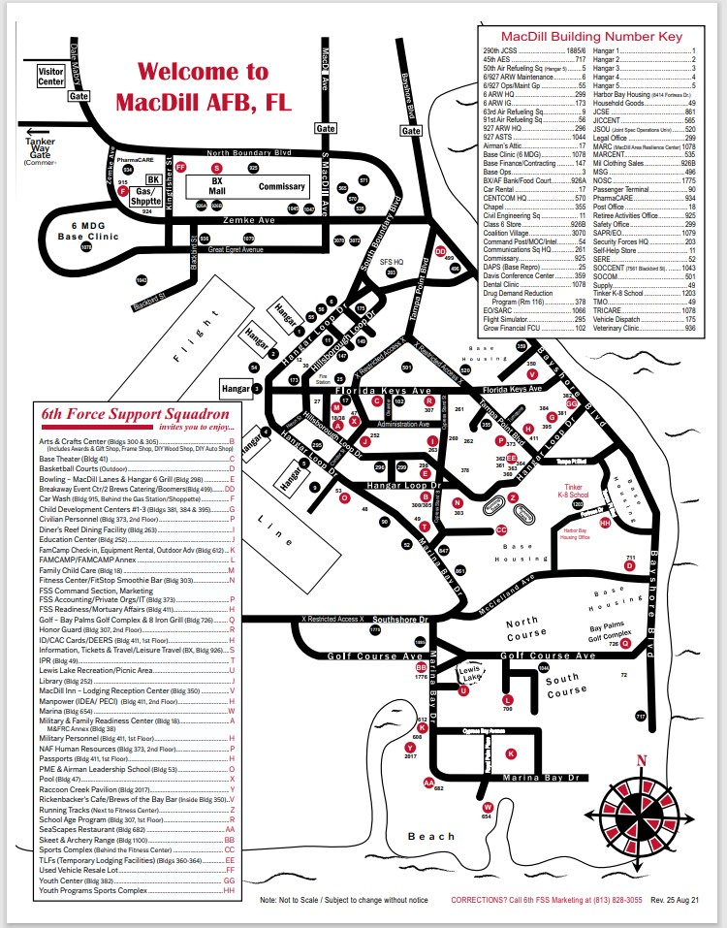
MAP (Click link for updates) MACDILL BASE MAP

Tampa Bay Area Attractions
The listing of these local area businesses and attractions is for general information purposes only. Their listing does not constitute an endorsement by the U.S. Air Force or USCENTCOM of their products or services. The information is provided by the respective businesses, and while we endeavor to keep the information up to date and correct, we make no representations about the completeness, accuracy, reliability, suitability or availability with respect to the products, services, or related graphics contained on their websites for any purpose. Any reliance you place on such information is therefore strictly at your own risk.
https://www.tampagov.net/visitors

Adventure Island 1-888-800-5447
www.adventureisland.com

Museum of Science & Industry (813) 920-4130
www.mosi.org

Busch Gardens 1-888-800-5447
www.buschgardens.com

Tampa Bay Buccaneers (813) 870-2700
www.buccaneers.com

Big Cat Rescue (813) 920-4130
www.bigcatrescue.org

Tampa Bay Lightning (813) 223-7999
www.nhl.com/lightning

Channelside (813) 223-4250
www.channelsidebayplaza.com

Tampa Bay Rays (813) 228-7157
www.RaysBaseball.com

The Florida Aquarium (813) 273-4000
www.flaquarium.org

The Tampa Museum of Art (813) 274-8130
www.tampamuseum.org

Lowry Park Zoo (813) 935-8552
www.lowryparkzoo.com

Yacht Starship Cruises (813) 223-7999
www.yachtstarship.com

Tampa Bay Area Map
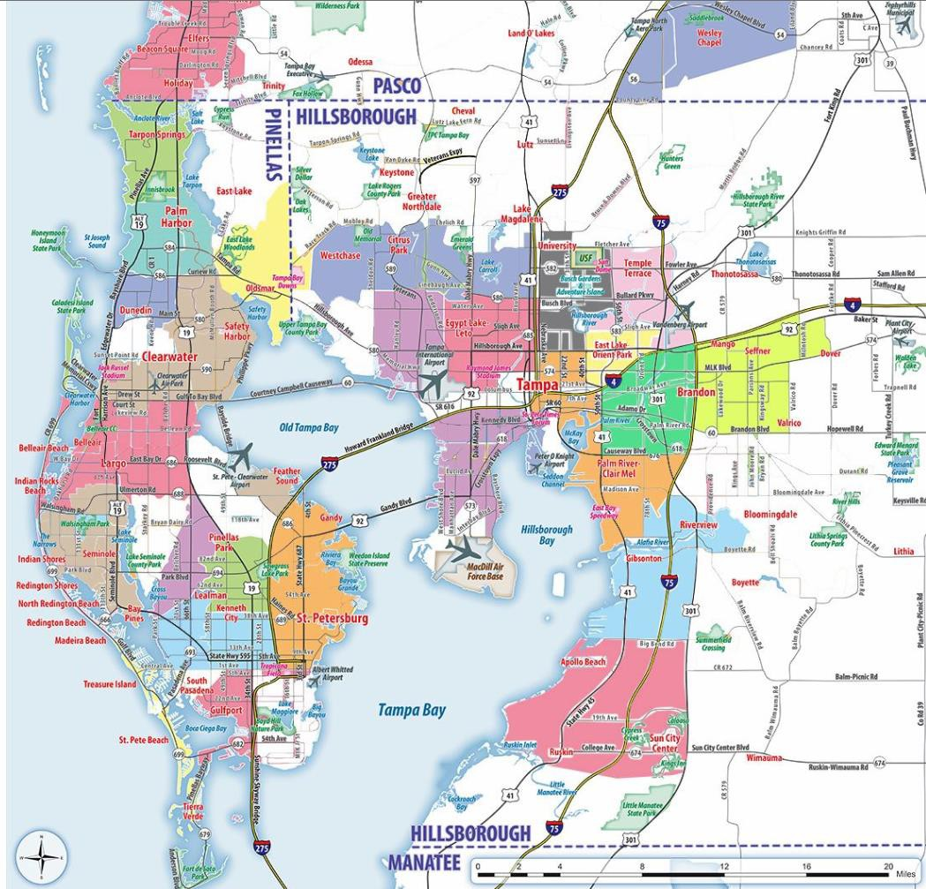
https://www.orangesmile.com/travelguide/tampa/high-resolution-maps.htm

Central Tampa Map
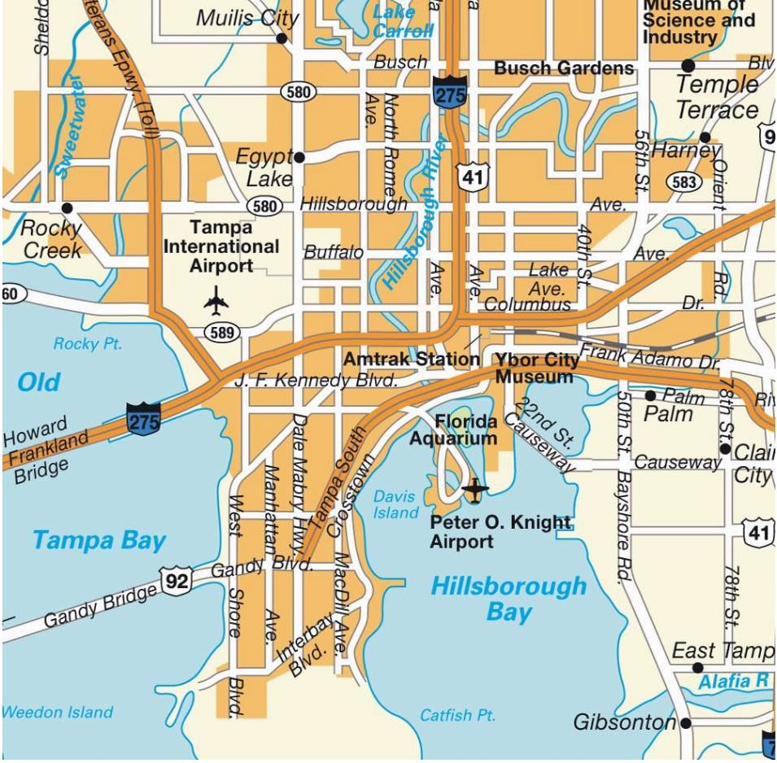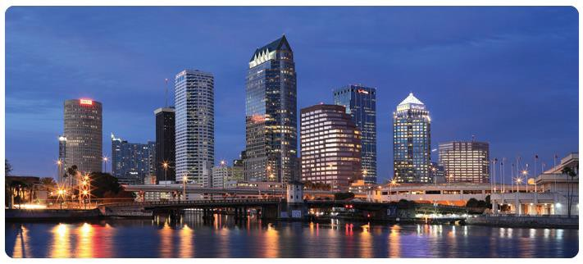

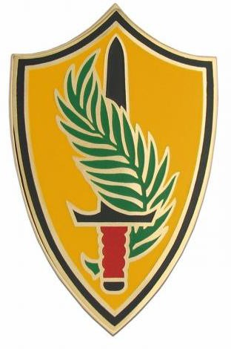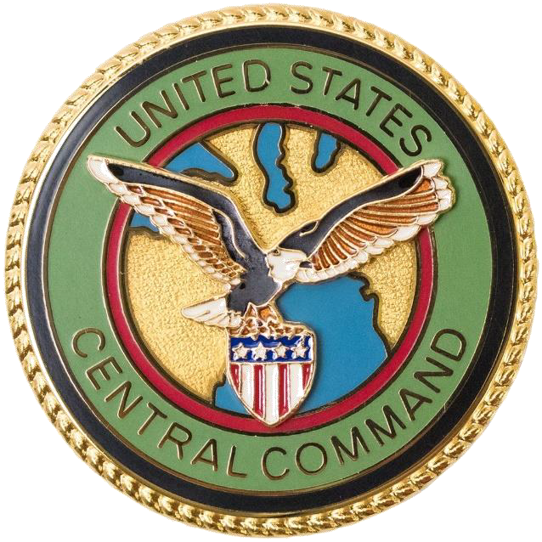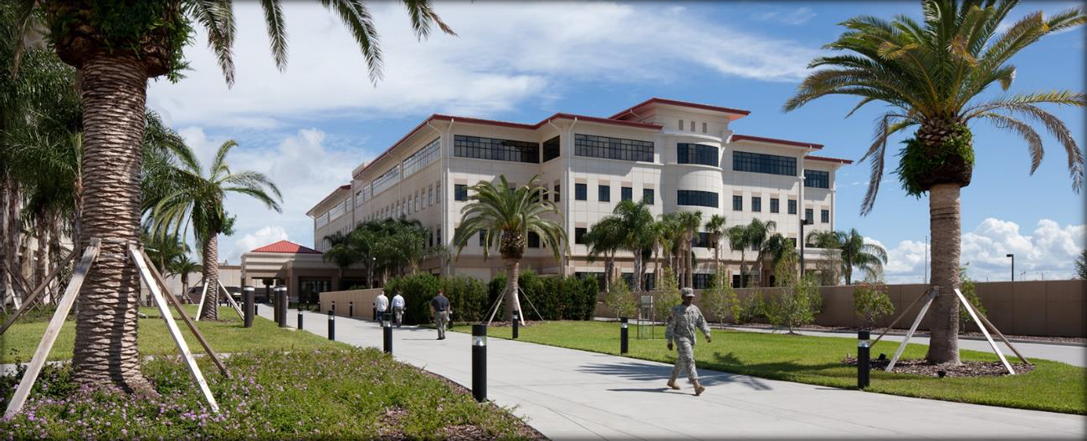

28

